Entrepreneurship and Community Development  p-ISSN/e-ISSN: 2987-6354/2987-6346  Homepage: https://sanscientific.com/journal/index.php/ecd  x(x) xx-xx (20xx)   https://doi.org/ | 

Original Paper (7-11 pages)

The title should be interesting, informative, and specific according to the content of the article (Max 16 words)-Trebuchet MS 16

First author’s name^{1*}, Second author², Third author³ (Trebuchet MS Size 12-Bold)
¹Faculty, University, City (Trebuchet MS size 10)
²Faculty, University, City (size 10)

³Faculty, University, City (size 10)

Corresponding author: full name (email)
Received: 20xx; Accepted: 20xx;

Abstract (Trebuchet MS size 12)-Bold
Abstracts are summaries/extracts of articles (manuscript) consisting of objectives, problems, implementation methods, results, benefit, conclusions, and managerial implications/ contributions. Maximum of 200 words. (Font Calisto MT; 10)

Keywords:

Abstrak (Trebuchet MS size 12)-Bold
Abstrak berupa ringkasan/sari artikel abdimas yang terdiri dari tujuan, fenomena masalah, metode implementasi, hasil, manfaat, konklusi dan implikasi manajerial/kontribusi. Ditulis maksimal 200 kata, Dalam dua bahasa: English dan Bahasa Indonesia. (Font Calisto MT; 10)

Kata Kunci: (Font Calisto MT; 10)

JEL Classification: American Economic Association: JEL Guide (aeaweb.org)

How to cite:

This is an open-access article under the CC-BY-SA international license

1. Introduction/Latar Belakang (Trebuchet-12)
The introductory section contains background, problem formulation, activity objectives, and literature review. Writers are required to describe quantitatively the portraits, profiles, and conditions of the target audience involved in community service activities. It can also describe the condition and potential of the area in terms of physical, social, economic and environmental relevance to the activities carried out. Also describe the potential that is used as material for community service activities. The author is asked to formulate the problem(s) concretely and clearly in this section. Explain the goals to be achieved in service activities. (Calisto MT 11).

This section is supported by a literature review which is used as a support for the concept of service. Authors are required to present primary and up-to-date literature reviews (references to journal articles and conference proceedings) (references published within the last 10 years). Literature review is not limited to theory, but also empirical evidence. Enrich this introductory section with the efforts that have been made by other parties. (Calisto MT 11).

2. Method/Metode/Implementasi (Trebuchet-12)
In the implementation method section, clearly and concisely describe the method used to achieve the goals set in the community service activities. The results of the dedication must be measurable and the writer was asked to explain the measuring instrument used, both descriptively and qualitatively. Explain how to measure the level of achievement of the success of community service activities. The level of achievement can be seen from the attitude, socio-cultural and economic changes of the target community. (Calisto MT-11)

3. Results/Hasil (Trebuchet-12)
Community service is an effort to disseminate science, technology and art to the community. These activities must be able to provide an added value to the community, both in economic activities, policies, and behavior change (social). Describe that service activities have been able to make changes to individuals/communities and institutions, both short and long term. (Calisto MT-11)

In this section, describe how the activities are carried out to achieve the goal. Explain the indicators of achieving the goals and the benchmarks used to indicate the success of the community service activities that have been carried out. Disclose the advantages and disadvantages of the output or the main focus of the activity when it is seen that it is in accordance with the conditions of the community in the activity location. Also explain the level of difficulty in carrying out activities and production of goods and opportunities for future development. Articles can be strengthened with relevant documentation related to services or goods as outputs, or the main focus of activities. Documentation can be in the form of pictures of the implementation or implementation process, pictures of product prototypes, tables, graphs, and so on. (Calisto MT-11)

Tables and Figures
Tables and figures are part of the manuscript and cannot be separated from the body of the manuscript. Place tables and figures where appropriate to the narrative so they complete the narrative. Tables and figures are numbered sequentially based on the order in which they appear in the text. Tables and figures must be given a title. These numbers are followed by the title of the table and figure. Table display can be seen in Table 1. (Calisto MT-11)

Table 1. Results of VAR and TVA test
 | P Value
 | 2013 | 2014 | 2015 | 2016 | 2017 | 2018 | 2019
Panel A: VAR
T +/- 1 | 0,511 | 1 | 0,880 | 1 | 0,775 | 1 | 0,892
T +/- 2 | 0,907 | 0,910 | 0,915 | 0,576 | 0,762 | 0,624 | 0,923
Panel B: TVA

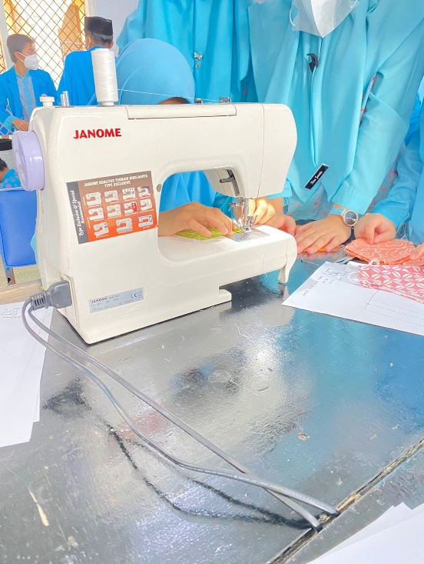 | 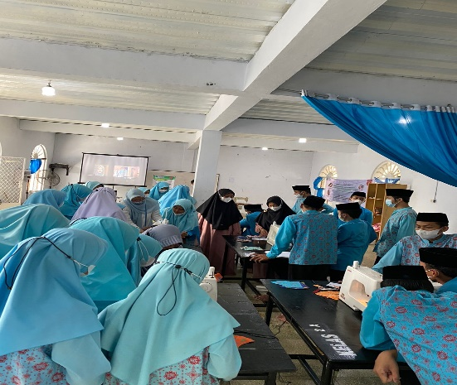

Figure 1. Activity

4. Discussion and Benefits/Pembahasan dan Manfaat (Trebuchet-12)
Discussion is a crucial part of a scientific article where an in-depth interpretation of the results and benefit of a your study of community development. The discussion should involve a dynamic process and comparison with some relevant previous studies based on specific scholarship. Discuss each result carefully to produce representative conclusions and following the objectives and benefits of the study. This part should explore the significance of the results and benefit of the work, not repeat them. A combined Results and Discussion section is often appropriate. Avoid extensive citations and discussion of published literature. (Calisto MT-11)

5. Conclusion/Simpulan (Trebuchet-12)
The conclusion summarizes the results of the discussion of the results and findings of the study. This section is the main idea of the scientific article (main idea) that is in line with the purposes of the article. Suggest the conclusion present in 3-4 paragraphs of medium size with the last paragraph is improvement and managerial implications. (Calisto MT-11)

Recommendations/Rekomendasi (Trebuchet-12)
Give advice and recommendations to parties who are relevant and related to this study. Suggestions should be specific, informative, and actionable (70-120 words). (Calisto MT-11)

Limitations and avenue for future community services (Keterbatasan dan Pengabdian Masyarakat Lanjutan) (Trebuchet-12)
Explain in one paragraph (max 70 words) the limitations of the article that we compiled are related to the purpose/problem, the data, and the method or design of the analysis. This article should also provide input for an avenue for future research. (Calisto MT-11)

Acknowledgment/Ucapan Terima kasih (Trebuchet-12)
This section is an opportunity for the author(s) to thank those who have contributed to the research and the article, such as providers of research funds (grants), institutions/individuals who provide data or analytical facilities, and experts/reviewers who provide valuable input (max 60 words). (Calisto MT-11)

Funding/Pendanaan (Trebuchet-12)
Please supply all details required by any funding and grant-awarding bodies as Funding in a separate paragraph as follows:
- For single agency grants:
  - This work was supported by the <Funding Agency> under Grant [number xxxx].
- For multiple agency grants:
  - This work was supported by the <Funding Agency #1> under Grant [number xxxx]; <Funding Agency #2> under Grant [number xxxx]; and <Funding Agency #3> under Grant [number xxxx].

Note: Manuscript/naskah: 10-15 pages in length.

ORCiD ID: (Author(s), if any) https://orcid.org/signin

References/Referensi (Trebuchet-12)
Author(s) should use references/papers on entrepreneurship and community service for the last 10 years sourced from Sinta-accredited national journals and/or international journals indexed by DOAJ, EBSCO, Copernicus/Scopus/WoS. The minimum number of references is 10 papers and it is preferable to have a DOI. (Calisto MT-10)

Citation in text/Sitasi pada naskah
The journal uses the APA (American Psychological Association) 7th Edition Style (author-date method) short reference system for citations in the text with an alphabetical list at the end of the paper use Mendeley or other aplications. Please ensure that every reference cited in the text is also present in the reference list and vice versa. Please check if all names and surnames of the authors, also the details (title, year, volume, pages, etc.) in the list of references are correct. Unpublished results and personal communications are not recommended in the reference list but may be mentioned in the text. Suppose these references are included in the reference list. In that case, they should follow the standard reference style of the journal and should include a substitution of the publication date with either 'Unpublished results' or 'Personal communication.'

In the text use the following style examples:
- This was explained by Allen (2020)" – single author item
- This was explained in full (Allen, 20206)" – single author item
- This was Concluded in full (Allen & Santosa, 2020) – two authors
- This was discussed in full (Huda et al., 2019)…" – 3 or more authors
- This was stated in full (P. Allen, 2019; S. Allen, 2020)…" where items have similar author names
- This was discussed in full (Allen, 2016a, 2016b)…" where two or more items are published in the same year

Web references
As a minimum, the full URL should be given and the date when the reference was last accessed. If known (DOI, author names, dates, reference to a source publication, etc.), should also give any further information. Web references can be listed separately (e.g., after the reference list) under a different heading if desired or included in the reference list.

Reference style
Text: Citations in the text should follow the referencing style used by the American Psychological Association. You are referred to the Publication Manual of the American Psychological Association, Sixth Edition. List: references should be arranged first alphabetically and then further sorted chronologically if necessary. More than one reference from the same author(s) in the same year must be identified by the letters 'a', 'b', 'c', etc., placed after the year of publication.

Examples:

Reference to a journal publication:
Santosa, P. W. (2020). Determinants of price reversal in high- frequency trading: empirical evidence from Indonesia. Investment Management and Financial Innovations, 17(1), 175-187. doi:10.21511/imfi.17(1).2020.16
Conrad, J., Wahal, S., & Xiang, J. (2015). High-frequency quoting, trading, and the efficiency of prices. Journal of Financial Economics, 116(2), 271-291. https://doi. org/10.1016/j.jfineco.2015.02.008
Reference to a journal publication with an article number:
Van der Geer, J., Hanraads, J. A. J., & Lupton, R. A. (2018). The art of writing a scientific article. Heliyon, 19, e00205. doi:10.1016/j.heliyon.2018.e00205.
Reference to a book:
Montgomery, D. C. (2012). Introduction to statistical quality control (7th ed.). London: Wiley.
Reference to a book chapter:
Slack, B. (2007). The terminalisation of seaports. In J. Wang, D. Olivier, T. Notteboom, & B. Slack (Eds.), Ports, cities, and global supply chains (pp. 41–50). Ashgate.
Reference to a website:
Cancer Research UK. Cancer statistics reports for the UK. (2003). http://www.cancerresearchuk.org/aboutcancer/statistics/cancerstatsreport/ Accessed 13 March 2003.
Conference proceedings
Saraiji, R., Harb, A., & Hamdan, M. O. (2011). Performance of LED street lights in hot environments. In K. Domke & C. A. Brebbia (Eds.), Light in engineering, architecture and environment (pp. 147–158). WIT Press. https://doi.org/10.2495/LIGHT110131
Brown, S., & Caste, V. (2004, May). Integrated obstacle detection framework. Paper presented at the IEEE Intelligent Vehicles Symposium, Detroit, MI.

Thesis or dissertation
Suwetwattanakul, C. (2010). Developing a knowledge sharing model for the implementation of the learning organization in Thailand (Unpublished doctoral dissertation/Thesis). Victoria University, Melbourne, Australia.
Internet documents
Bown, J. (2019, December 17). How charity apps may be making us more generous. BBC News. https://www.bbc.com/news/business-50572939
Dataset:
[dataset] Oguro, M., Imahiro, S., Saito, S., Nakashizuka, T. (2015). Mortality data for Japanese oak wilt disease and surrounding forest compositions. Mendeley Data, v1. http://sci-hub.tw/10.17632/xwj98nb39r.1.

Subdivision - numbered sections
Divide your article into clearly defined and numbered sections. Subsections should be numbered 1.1 (then 1.1.1, 1.1.2, ...), 1.2, etc. (the abstract is not included in section numbering). Use this numbering also for internal cross-referencing: do not just refer to 'the text'. Any subsection may be given a brief heading. Each heading should appear on its separate line.

Appendices
If there is more than one appendix, they should be identified as A, B, etc. Formulae and equations in appendices should be given separate numbering: Eq. (A.1), Eq. (A.2), etc.; in a subsequent appendix, Eq. (B.1) and so on. Similarly, for tables and figures: Table A.1; Fig. A.1, etc.

